Black-box Implementation of Quantum Vibration Perturbation Theory: Application to Acetophenone Solvatochromism and Hydrogen Bond Exchange Dynamics in 2DIR

Adam Grofe,1 Ivan C. Spector, 1 Aaron M. Massari, 1 Hui Li,2 and Jiali Gao1,2

1. Department of Chemistry, University of Minnesota

Minneapolis, Minnesota 55455, United States

1. Institute of Theoretical Chemistry, Jilin University

Changchun Jilin Province 130023, China

ABSTRACT:

We present a black-box implementation of quantum vibration perturbation (QVP) that requires minimal input from the user. By providing only the normal mode and the set of coordinates at which it was calculated, it is possible to compute the vibrational frequency. In this article, a coordinate transformation is defined to interpolate between different configurations during dynamics. Possible sources of error in this transformation are evaluated to show how the error in the perturbation can be reduced. This algorithm was then applied to the solvatochromism of acetophenone to yield a mean unsigned error of 2.2 cm-1 in the solvatochromic shifts at the level of PM3/OPLS-AA. Additionally, specific reaction parameters were optimized for PM3 to better characterize the acetophenone in methanol hydrogen bonding states. This PM3-SRP was then used to compute two-dimensional infrared photon echo spectra that show hydrogen bond exchange. The computed spectra agree with experiment to a reasonable degree of certainty, which suggests that QVP can be directly applicable to monitoring vibrational dynamics in the condensed phase.

TOC graphics.

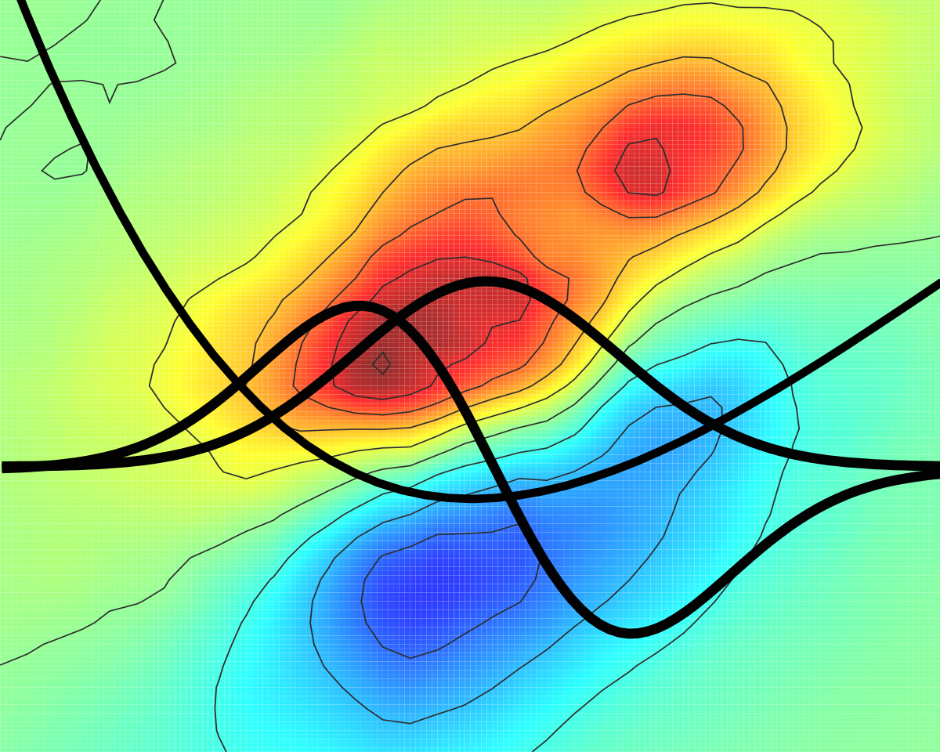

**1. Introduction**

Two dimensional infrared spectroscopy (2DIR) provides a lens into the microscopic environment on a time scale permissible to study dynamics.1-5 2DIR spectroscopy of the amide I band shows promise in the resolution of protein structures.2, 3, 6 Additionally, 2DIR permits the resolution of condensed phase hydrogen bond dynamics.7-10

At this stage in the development of 2DIR methods, computation provides unique insight into the interpretation of spectra through molecular simulation. A common part in the simulation of 2DIR signals is the evaluation of the vibrational frequencies for a molecular dynamics trajectory. The most popular approaches use a mapping procedure based on electrostatics.11-20 Historically, Cho proposed the use of electrostatic potential at key positions in the mode to determine the vibrational frequency based on a set of Hartree-Fock structures.21 Later the Cho group went on to generalize this principle for course graining to include greater sampling of the electrostatic potential and using density functional theory (DFT) structures for fitting,22, 23 and to include exchange and dispersion explicitly.24

Meanwhile, Skinner and coworkers13, 14 utilized the electric field instead of the electrostatic potential from a set of DFT structures to optimize a map. Skinner and coworkers12 formulated an electric field map the could be transferable between different environments, eg. different solvents. Mukamel and coworkers20 extended this idea to include more points in the map along with the first and second derivatives of the electric field. Interestingly, this form of electrostatic map parallels the work on linear Stark effect spectroscopy25-36 where the direct connection between solvatochromism and electric field effects can be seen. Additionally, this provides justification for the use of the electric field instead of the electrostatic potential. In practice, the electric field on the probed vibration mode is linearly related to the shift of the vibrational frequency using the equation

 (1)

where  is the difference in the dipole moment between the ground and excited vibrational states29, which is often called the linear Stark tuning rate, and  is the electric field of the environment on the normal mode. Linear Stark effect spectroscopy has been used to provide insight into microscopic electrostatics. For instance, Boxer and coworkers37 showed that a strong hydrogen bond is formed in ketosteroid isomerase that leads to a relatively fast rate constant due to hydrogen bond stabilization of the enolate intermediate.

As an empirical approach, anharmonic and quantum mechanical effects are included in an average sense into the parameterization for these maps. A particular advantage of the electrostatic map is that solvent effects on vibrational properties can be estimated efficiently. Nevertheless, one drawback is that each property needs to be parameterized separately; for example, the calculation of vibrational frequency and transition dipole moment require different electrostatic maps. Additionally, an electrostatic map needs to be optimized for each type of mode in consideration, and transferability between similar modes is questionable.

In principle, molecular vibration can be modeled directly by solving the vibrational Schrödinger equation, and this approach has been applied to numerous systems. **In this case, there is no need to specifically parameterize electrostatic maps for different molecules or operators.** Typically, this is not used because it is more time consuming. However, Li and coworkers8, 38 demonstrated a method, quantum vibration perturbation (QVP), that leads to performance increases by avoiding the diagonalization step and using perturbation theory, which scales much better at low orders. In this article, a simple implementation of the QVP approach is demonstrated that requires very little effort on the part of the user, which permits the direct application of QVP for large coordinate sets. The implementation was tested against the solvatochromism of acetophenone, which was extensively studies by Boxer and coworkers.26, 27 To further evince QVP’s utility, the 2DIR of acetophenone in methanol, a system that displays overt hydrogen bond exchange, was computed and compared to the experimental spectra.

**2. Methods**

The quantum vibration perturbation(QVP)38 approach is an efficient method for computing the instantaneous vibrational wave function of a probe molecule in condensed phases and in proteins. Additionally, its computational accuracy can be systematically improved. First, a discrete variable representation (DVR) is used to evaluate the integral matrix elements over quadrature points. Second, changes in the wave function and eigenvalues, for instance with respect to time, are determined using perturbation theory. The energetic terms can be represented using combined quantum mechanical and molecular mechanical (QM/MM) techniques to describe the vibrational chromophore and its solvent interactions. The details as to how this was implemented into the Charmm39 simulation package as a roughly black-box implementation are presented below.

**2.1 QVP Implementation**

The DVR that was implemented was due to Colbert and Miller40 for the interval (-∞,∞). This widely used DVR41 has several advantages with regards to implementation. First, the basis set for the Hamiltonian is the infinite basis of evenly spaced sinc functions, which are already localized meaning that the position operator is diagonal. Thus, the positions of the sinc functions are the Gaussian quadrature points.41 Secondly, the kinetic energy operator is exact for the infinite set of basis functions. Typically, the basis set is truncated, thus, making the kinetic energy approximate. However, the effect of this approximation exponential diminishes outside the classically allowed region of phase space42 so for practical purposes this DVR converges for a sufficiently large basis. Thirdly, the full definition of this DVR only requires two parameters: the grid spacing and the number of basis functions. The grid spacing defines an upper bound to the kinetic energy.42 For this definition of the DVR, the Hamiltonian operator is

$$\begin{aligned}H_{ii}=\frac{ℏ^{2}π^{2}}{6mΔx^{2}}+V\left(x_{i}\right)\#\left(2\right)\end{aligned}$$

$$\begin{aligned}H_{ij}=\frac{ℏ^{2}{\left(-1\right)}^{i-j}}{mΔx^{2}{\left(i-j\right)}^{2}} for i≠j\#\left(3\right)\end{aligned}$$

where $m$ is the reduced mass, $Δx$ is the grid spacing, $V\left(x_{i}\right)$ is the potential energy at the DVR point. The common DVR approximation41, 43 of assuming a diagonal form of the potential energy operator is used.

The Colbert and Miller DVR is general enough for direct application in QVP, but the goal of the QVP method is provide both speed and accuracy. Furthermore, the goal is to have a method that allows for fast computation of ab initio frequencies, which require reducing the number of energy calculations in the computation of the DVR, and for calculation of a large number of frequencies quickly to be used in analysis of a molecular dynamics trajectory. Therefore, it is advantageous to further trim the number of basis functions/DVR points using potential optimization.

Potential optimized DVR (PO-DVR)44, 45 uses the information given by the potential energy to determine the optimal points to use. This is done through a two step procedure. First, the Hamiltonian is solved in the original basis. Next, the position operator is calculated for the truncated basis using the lowest $N^{PO}$ eigenvectors, which is subsequently diagonalized to yield the PO-DVR points. This transformation can be summarized in the equation

$$\begin{aligned}x^{PO}={V^{†}U}^{†}xUV\#\left(4\right)\end{aligned}$$

where $U$ is the rectangular matrix of eigenvectors for the Hamiltonian in the original basis. The dimensions of this matrix is $N^{DVR}$ x $N^{PO}$. $V$ is the unitary matrix that diagonalizes the optimized basis position operator. The $x^{PO}$ and $x$ matrices are diagonal and represent the PO-DVR and DVR points respectively. The same transformation is performed on the Hamiltonian, and then diagonalized to yield the eigenvalues and eigenvectors of the PO-DVR basis.

The second part of the QVP method is to use perturbation theory to update the eigenvectors and eigenvalues. Here we define the QVP energy as

$$\begin{aligned}E\left(r_{i}\right)=E^{0}\left(r^{ref}\right)+ΔE\left(r_{i}\right)\#\left(5\right)\end{aligned}$$

where $E_{i}\left(r_{j}\right)$ are the configuration dependent energy eigenvalues for the nuclear wave function, $E_{i}^{0}\left(r^{ref}\right)$ are the reference eigenvalues and $ΔE_{i}\left(r_{i}\right)$ is the time independent perturbation correction using the equations Raleigh-Schrödinger perturbation theory.46 The perturbation operator here is defined as the difference between the potential energy of configuration *j* as compared to the reference configuration. However, these are general configurations; QVP would work just as well with Monte Carlo as it would molecular dynamics, but for molecular dynamics the configurations are a time dependent trajectory. Because we are using a DVR, the calculation of the perturbation operator only requires single point energies at the DVR points. The advantage of using perturbation theory to update the nuclear wave functions is that this fundamentally scales better than DVR due to the diagonalization step and prior optimization of the basis reduces the number of basis functions required. Diagonalization scales as $O\left[{\left(N^{DVR}\right)}^{4}\right]$ while the first and second order of perturbation theory scales as ${O[\left(N^{DVR}\right)}^{2}]$.

**2.2 Transformation Matrix for the Normal Mode**

The goal is to provide a black-box procedure in the calculation of vibrational frequencies without much user input. This means that it is necessary to calculate the frequency while the mode is moving about in space. Therefore, it is necessary to transform the coordinates, or conversely the normal mode, as the probe moves through space during the simulation so that the same eigenvector can be used throughout the analysis. To accomplish this, we begin with the algorithm presented by Arun et al.47 in the realm of computer vision. They present an algorithm to calculate the transform from a reference set of points to a modified set as would occur during the movement of a roughly rigid body. The transformation between these sets can be defined as

$$\begin{aligned}r_{i}^{ref}=Tr_{i}+ R^{com}+ζ_{i}\#\left(6\right)\end{aligned}$$

where $r_{i}$ is the coordinate set of interest, $r_{i}^{ref}$ is the reference set of coordinates, $R^{com}$ is the translation of the center of mass, $ζ_{i}$ is a noise term, in this application of the algorithm this refers to displacements along internal coordinates of the molecule. The index in equation 6 is over atoms in the normal mode. $T$ is the rotation matrix between the coordinate frames. $R^{com}$ can be computed exactly based on the centers of mass of the two coordinate sets. Meanwhile, $ζ$ can be computed approximately (see discussion at the end of this section). The calculation of the rotation matrix (***T***) is nontrivial and is the cornerstone of this algorithm. We begin with

$$\begin{aligned}S=\sum_{i}^{N_{a}}{Δr_{i} {\left[Δr_{0}\right]}_{i}^{T} }\#\left(7\right)\end{aligned}$$

where $Δr_{i}$ and $\left[Δr_{0}\right]$ are the concentric position vectors of the *i*th atom with the centers of mass at the origin, and $N_{a}$ is the number of atoms. ***S*** is a 3 x 3 matrix, and is conceptually similar to a covariance matrix. Next, a singular value decomposition is performed on $S$.

$$\begin{aligned}s=U^{T}S V \#\left(8\right)\end{aligned}$$

where $s$ is the diagonal matrix of singular values and ***U*** and ***V*** are the left and right singular vectors. In the Arun *et al*. algorithm the rotation matrix is

$$\begin{aligned}T=VU^{T} \#\left(9\right)\end{aligned}$$

Arun *et al*. showed that this is the least squares solution for rotation, and note that this algorithm may yield incorrect solutions to the rotation in systems with high symmetry. In these cases, the transformation matrix becomes one of the other symmetry elements in the point group, such as a reflection. This is due to error cancellation of the points in the least squares procedure. We propose a slight modification to their algorithm to eliminate the effect of these incorrect solutions. Specifically, weighting the covariance matrix according to the magnitude of the normal mode displacements:

$$\begin{aligned}S=\sum_{i}^{N_{a}}{|{q_{i}|}^{2}\left(Δr_{i} {[Δr_{0}]}_{i}^{T}\right)} \#\left(10\right)\end{aligned}$$

This modification includes relevant information into the calculation of the rotation matrix. In equation 7, the position vectors are weighted evenly, which makes the atoms indistinguishable. By introducing normal mode weighting, the atoms are distinguished in their importance. This prevents incorrect solutions due to symmetry, or at the very least would remain in the proper point group for vibrationally indistinct atoms.

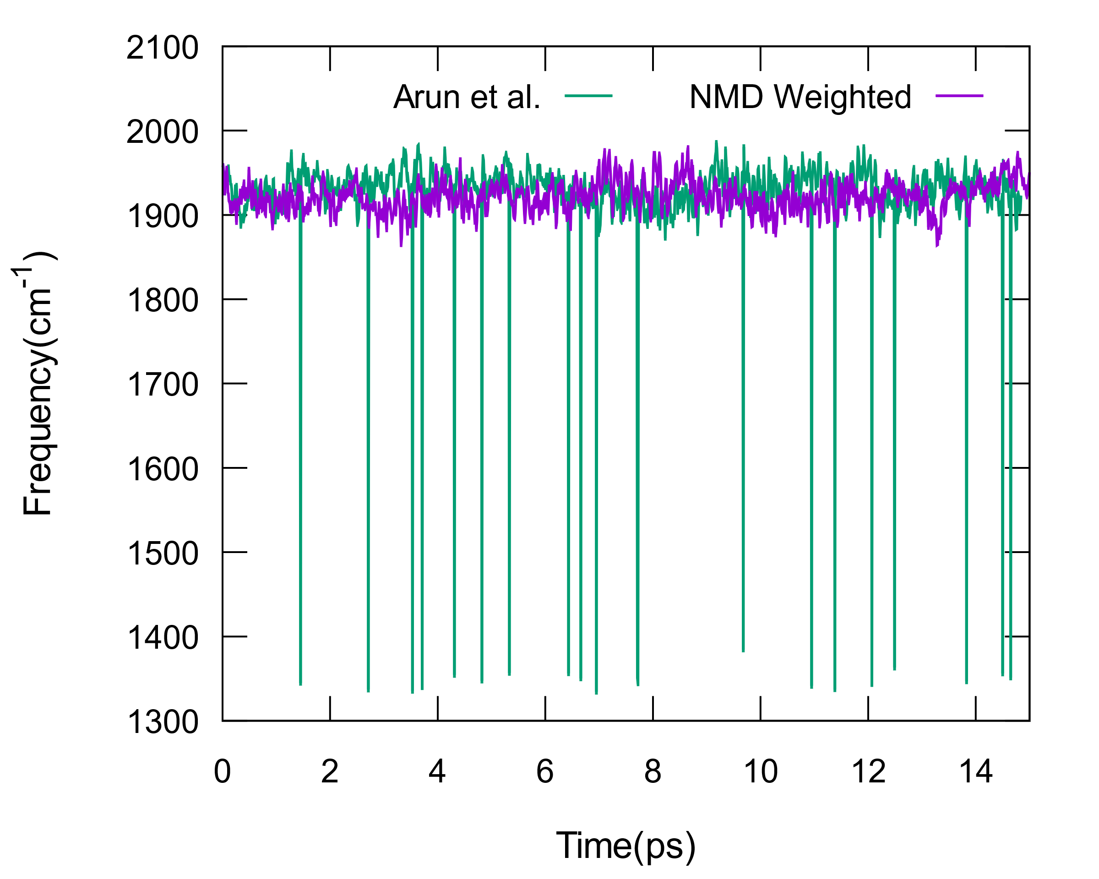

**Figure 1.** Frequency trajectories computed using the Arun et al. algorithm for the rotation matrix and the normal mode displacement (NMD) weighted algorithm presented in equation 10.

In the application of the Arun *et al*. algorithm to the carbonyl vibration in acetophenone, it was relatively simple to determine whether the transformation failed. The carbonyl vibration is a relatively high frequency mode, which means that any rotation other than the true rotation would yield a frequency that is several hundred to a few thousand wavenumbers lower. In these cases, the carbonyl stretch essentially becomes an angle bending vibration. Figure 1 shows a data set that has incorrect solutions using the algorithm of Arun *et al.* that is corrected when using equation 9.

This transformation allows for the direct application of a normal mode computed at a reference geometry, and, thus, allows QVP to be applied as a black-box for given set of coordinates. However, it does introduce a restriction on the normal mode atoms for the optimal performance of the transformation. The rough spatial relationships of the normal mode atoms to each other should be maintained. For instance, normal mode displacements for atoms that move along a torsional angle would be invalid for the normal mode calculated at a specific torsional angle. This restriction can be simply rectified by using localized modes in which torsional free atoms have very small displacements.

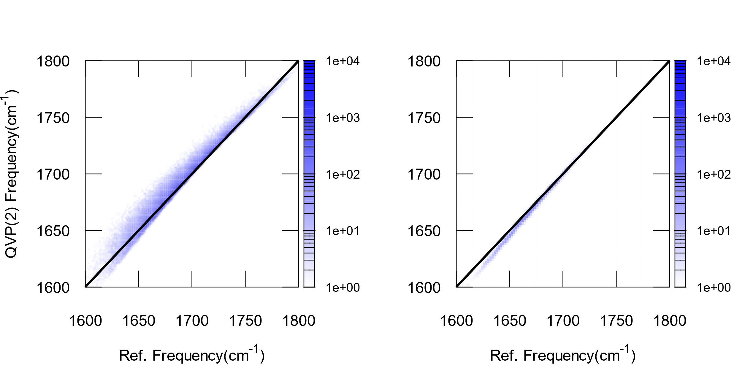

**Figure 2.** Frequency histograms comparing the frequency calculated with 50 DVR points (Reference) and the QVP2 frequency. The left figure shows the error in the perturbation when $ζ_{i}$ is neglected, and the right shows when $ζ_{i}$ is calculated with 500 steps of adopted basis Newton-Raphson minimization. 200,000 frequencies were computed from the acetophenone/water simulations.

Equation 6 was the starting point for the coordinate transformation, but is not necessarily the true goal of the transformation in this context. The goal is to move the normal mode coordinates to a minimum on the potential energy surface for several reasons. First, the PO-DVR points are optimized with the minimum at the origin, and displacement away results in large changes in the wave function, which begins to limit the accuracy of the perturbation approximation. Additionally, this error cannot be further corrected by including more basis functions. The average error in the perturbation is -2.1 cm-1 for 10 PO-DVR points, and -2.0 cm-1 for 20 PO-DVR points. Throughout the study, 10 PO-DVR points were used to represent the wave function in QVP2. A histogram showing the spatial distribution of the perturbation error is shown in figure 2. Another reason the $ζ_{i}$ should displace to a minimum is that this roughly treats dynamic coupling for modes orthogonal to the mode of interest.

$ζ_{i}$ was calculated by constraining the positions of all atoms except for those that participate in the normal mode. Then performing 500 steps of adopted basis Newton-Raphson minimization. Further study is needed on the minimum number of steps required, but $ζ_{i}$ is fully converged (the root mean square of the force is approximately zero) with the minimization often finishing before 500 steps. Figure 2 shows that the spatial distribution of the error is dramatically reduced. The average error in the perturbation is 2.4 cm-1.

**2.4 Computational Details**

Molecular dynamics simulations were performed in the isothermal-isobaric ensemble at 1 *atm* and 298 *K* for a single acetophenone solute in solvent boxes of ca. 40 × 40 × 40 Å3. The solvents considered in this work cover a wide range of polarities, including carbon tetrachloride (CCl4), n-hexane, diethyl ether (DEET), N,N-dimethyl acetamide (DMA), chloroform (CHCl3), acetonitrile (MeCN), methanol (MeOH) and water. All calculations were performed using a locally modified version of the CHARMM software package39. The potential energy surface was described using a combined quantum mechanics and molecular mechanics (QM/MM) approach, in which the solute, acetophenone, was represented by PM348-50 and the organic solvents are modeled with the OPLS-AA51, 52 force field. Following an initial equilibration, molecular dynamics was carried out for 2-4 *ns* at a 1-fs time step, during which coordinates were saved on every 10 *fs*, sufficient for the analyses and Fourier transform of the response functions. The normal mode was determined in a similar fashion to reference (Olson, Grofe…), and QVP calculations were performed at the second-order perturbation level, called QVP2.

The QVP model provides a trajectory of vibrational frequencies from that it is possible to calculate the linear infrared (IR) spectrum and the nonlinear 2DIR numerically based on the response formalism.53, 54 The linear absorption line shape55-57 was calculated using

$$\begin{aligned}I\left(ω\right) \sim Re \int_{0}^{t_{max}}{dt e^{-i\left\langle ω\right\rangle t}⟨exp⁡[i\int_{0}^{t}{dt^{'} δω(t^{'})] ⟩\exp\left[-\frac{t}{2T_{1}}\right] }} \#\left(10\right)\end{aligned}$$

where,  is population relaxation time from the excited vibrational state. Additionally, the two dimensional photon echo spectra were computed using a similar derivation of the nonlinear response functions.56 This derivation of the response functions permits modelling of the non-gaussian fluctuations,57 which is specifically useful for systems that have hydrogen bonding character or separated ensembles.10 For this system, modelling non-gaussian fluctuations is important for acetophenone in methanol which displays two overlapping peaks for different hydrogen bond configurations (see Figure XX and the supporting information of reference58). Kwac and Cho57 showed that using the second cumulant expansion response functions does not adequately model non-gaussian fluctuations, and yields a single peak instead of two overlapping peaks.

One of the advantages of the QVP model over others used in the modelling of 2DIR is the calculation of quantities other than the frequency. For instance, the third order response function56 used to calculate the 2DIR requires the transition dipole between states. Because QVP is a first principles method, it is possible to simultaneously compute vibrational frequencies, transition dipole moments, and other observables on-the-fly during simulation.

The linear Stark effect was analyzed in order to compare to Fried and coworkers26, 27, and the electric field in the present simulations was calculated in a similar manner to reference (Fried JACS Paper). Briefly, the electric field on carbon was computed by calculating the force of a positive test charge at the carbon position without any interactions with acetophenone so that the test charge is only interacting with the solvent reaction field. This was subsequently done for the oxygen position. These vectors were projected onto the bond vector, and averaged to yield the effective electric field on the mode. The equation is

$$E_{mode}= -\frac{1}{2}\left( E_{C}⋅r_{co}+E_{O}⋅r_{co}\right)$$

This was completed on all configurations and subsequently averaged.

**2.5 Experimental Details**

**4. Results and Discussion**

The QVP implementation was validated by calculating the vibrational Stark shifts for acetophenone in a variety of solvents. Overall, the computed spectra(Figure 1) shift toward the red as the polarity of the solvent increases as was observed by Boxer and coworkers.26, 27, 58 Table 1 compares the computed solvatochromic shift to those determined by experiment, and the computed values compare reasonably well with a mean unsigned error of 2.2 cm-1. The absolute frequencies were shifted by -252 cm-1 so that the simulated hexane absorption peak was aligned with experiment. It is well known that PM3 characteristically overestimates the vibrational frequency compared to experiment59, and the constant offset corrects this without affecting the solvatochromism within the model. The largest errors are due to acetophenone in carbon tetrachloride and chloroform both of which contain chlorine atoms.

The carbon tetrachloride simulations show almost no shift with respect to hexane and similarly displays a comparable electric field. It is possible that non-electrostatic terms play a significant role in the solvatochromism for this system. For instance, halogen atoms due to their larger size compared to hydrogen display a larger polarizability, which also correlates with dispersion. If we use the Lorentz-Lorenz equation60 as a way to approximate the polarization (see Table SI.XX), then carbon tetrachloride, chloroform and N,N-dimethylacetamide display a notable increase compared to the other solvents, which suggests that the error in the solvatochromic shift of these solvents could be alleviated through the explicit treatment of solvent polarization. QVP permits higher levels of accuracy can be built into the model through the potential energy surface, thus, allowing for the proper treatment of all effects.

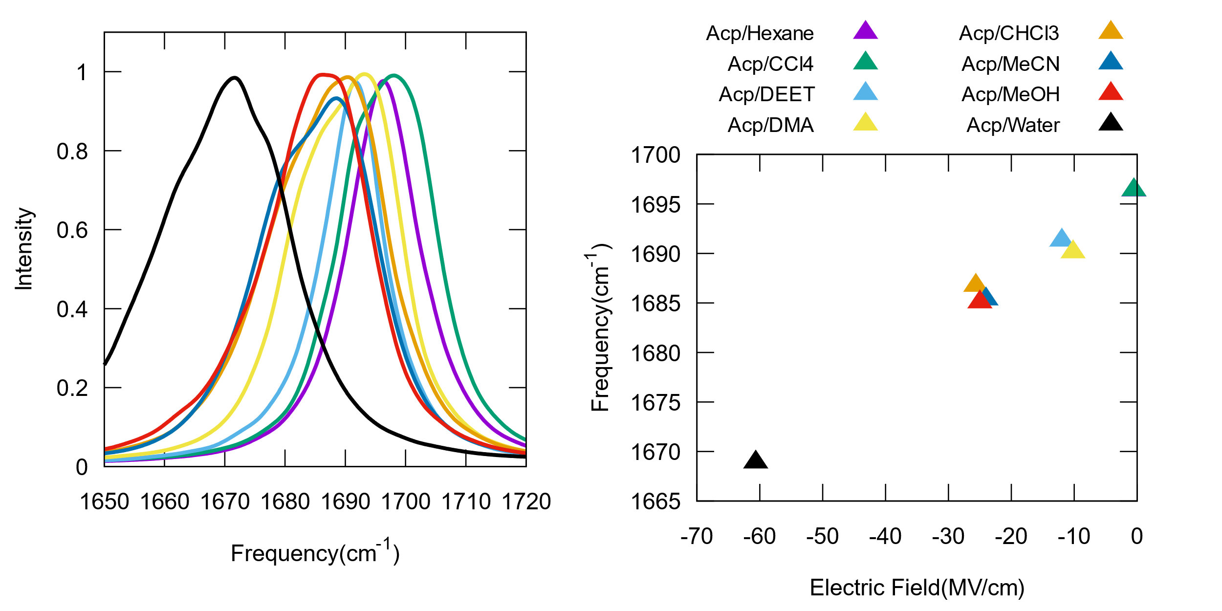

**Figure 3.** Left: Calculated linear infrared spectra of the carbonyl vibration of acetophenone in a variety of solvents. All results were calculated from PM3/OPLS-AA simulations Right: Correlation between the carbonyl vibrational frequency and the electric field projected onto the normal mode. A linear regression of the correlation resulted in $ν\left(E_{mode}\right)=0.45 E_{mode}+1696.4$

**Table 1**. Computed peak positions from PM3/OPLS-AA simulations, and solvatochromic shifts of acetophenone in various solvents, compared to experimentally measured solvatochromic shifts. Hexane was used as the reference for all of the solvatochromic shifts.

|  |  |  |  |  |
| --- | --- | --- | --- | --- |
| Solvent System | $$ν_{calc}(cm^{-1})$$ | $$Δν_{calc}(cm^{-1})$$ | $$ν_{exp}(cm^{-1})$$ | $Δν_{exp}(cm^{-1})$ |
| Carbon Tetrachloride | 1696.4 | 0.0 | 1691.0a | -5.4 |
| Hexane | 1696.4 | 0.0 | 1696.4b | 0.0 |
| Diethyl Ether | 1691.3 | -5.1 | 1692.9b | -3.5 |
| N,N-dimethyl acetamide | 1690.2 | -6.3 | - | - |
| Acetonitrile | 1685.4 | -11.0 | 1686.1b | -10.3 |
| Chloroform | 1686.8 | -9.6 | 1683.3b | -13.1 |
| Methanol | 1685.1 | -11.3 | 1683.8c | -12.6 |
| Water | 1668.9 | -27.4 | 1669.4b | -27.0 |

a. Reference 61

b. Reference 27

c. Determined from Figure XX by averaging both peak positions

Furthermore, the PM3/OPLS-AA simulations were successful at reproducing the correct linear behavior between the vibrational frequency and the electric field. Overall, the electric fields compare well to those previously calculated by Boxer and coworkers.26, 27 A linear fit of the electric field correlation yields a linear Stark tuning rate of 0.45 cm-1/MV/cm, which is similar to previously computed values.26, 27 The computed frequency shift and electric field for carbon tetrachloride are both relatively small as compared to the experimental frequency shift, which further suggests that non-electrostatic effects could play a role in carbon tetrachloride solvatochromism.

Specific reaction parameters62, 63 were optimized for acetophenone to model the hydrogen bond dynamics in methanol. The Uss, Upp, βs and βp parameters of oxygen were optimized to yield a similar average frequency to acetophenone in the gas phase (NIST) from a 10 *ps* MD trajectory. The parameters are given in the supporting information. Only the oxygen parameters were optimized because this allows for the smallest change possible to the PM3 parameter set. Additionally, more focus was spent on modifying βs and βp because these parameters affect the coupling between atomic orbital basis functions. PM3 displays a higher frequency than experiment (~1940 vs 1702 for the gas phase). Decreasing βs and βp by a factor of 0.925 diminishes the coupling between the carbon and oxygen elements of the Fock matrix, thus reducing the bond order of the carbonyl. Meanwhile, the magnitude Uss and Upp were increased by a factor of 1.075 for the same reason. Increasing the energetic difference between the carbon and oxygen electronic wave functions leads to less mixing, and, also, reduces the bond order.

The goal of this PM3-SRP was to reduce the bond order of the carbonyl to yield a vibrational frequency similar to experiment with as little change to the PM3 parameters as possible, and to also make the mode more sensitive to hydrogen bonding. The acetophenone in methanol spectrum at the level of PM3/OPLS-AA does not display the double peak that is present in experiment. Decreasing the coupling between carbon and oxygen leads to the bond being more polarized, which increases the difference dipole making the mode more sensitive to the environment. The PM3-SRP was applied to the other eight solvents, but lead to excessive sensitivity with respect to the electric field to be applicable globally.

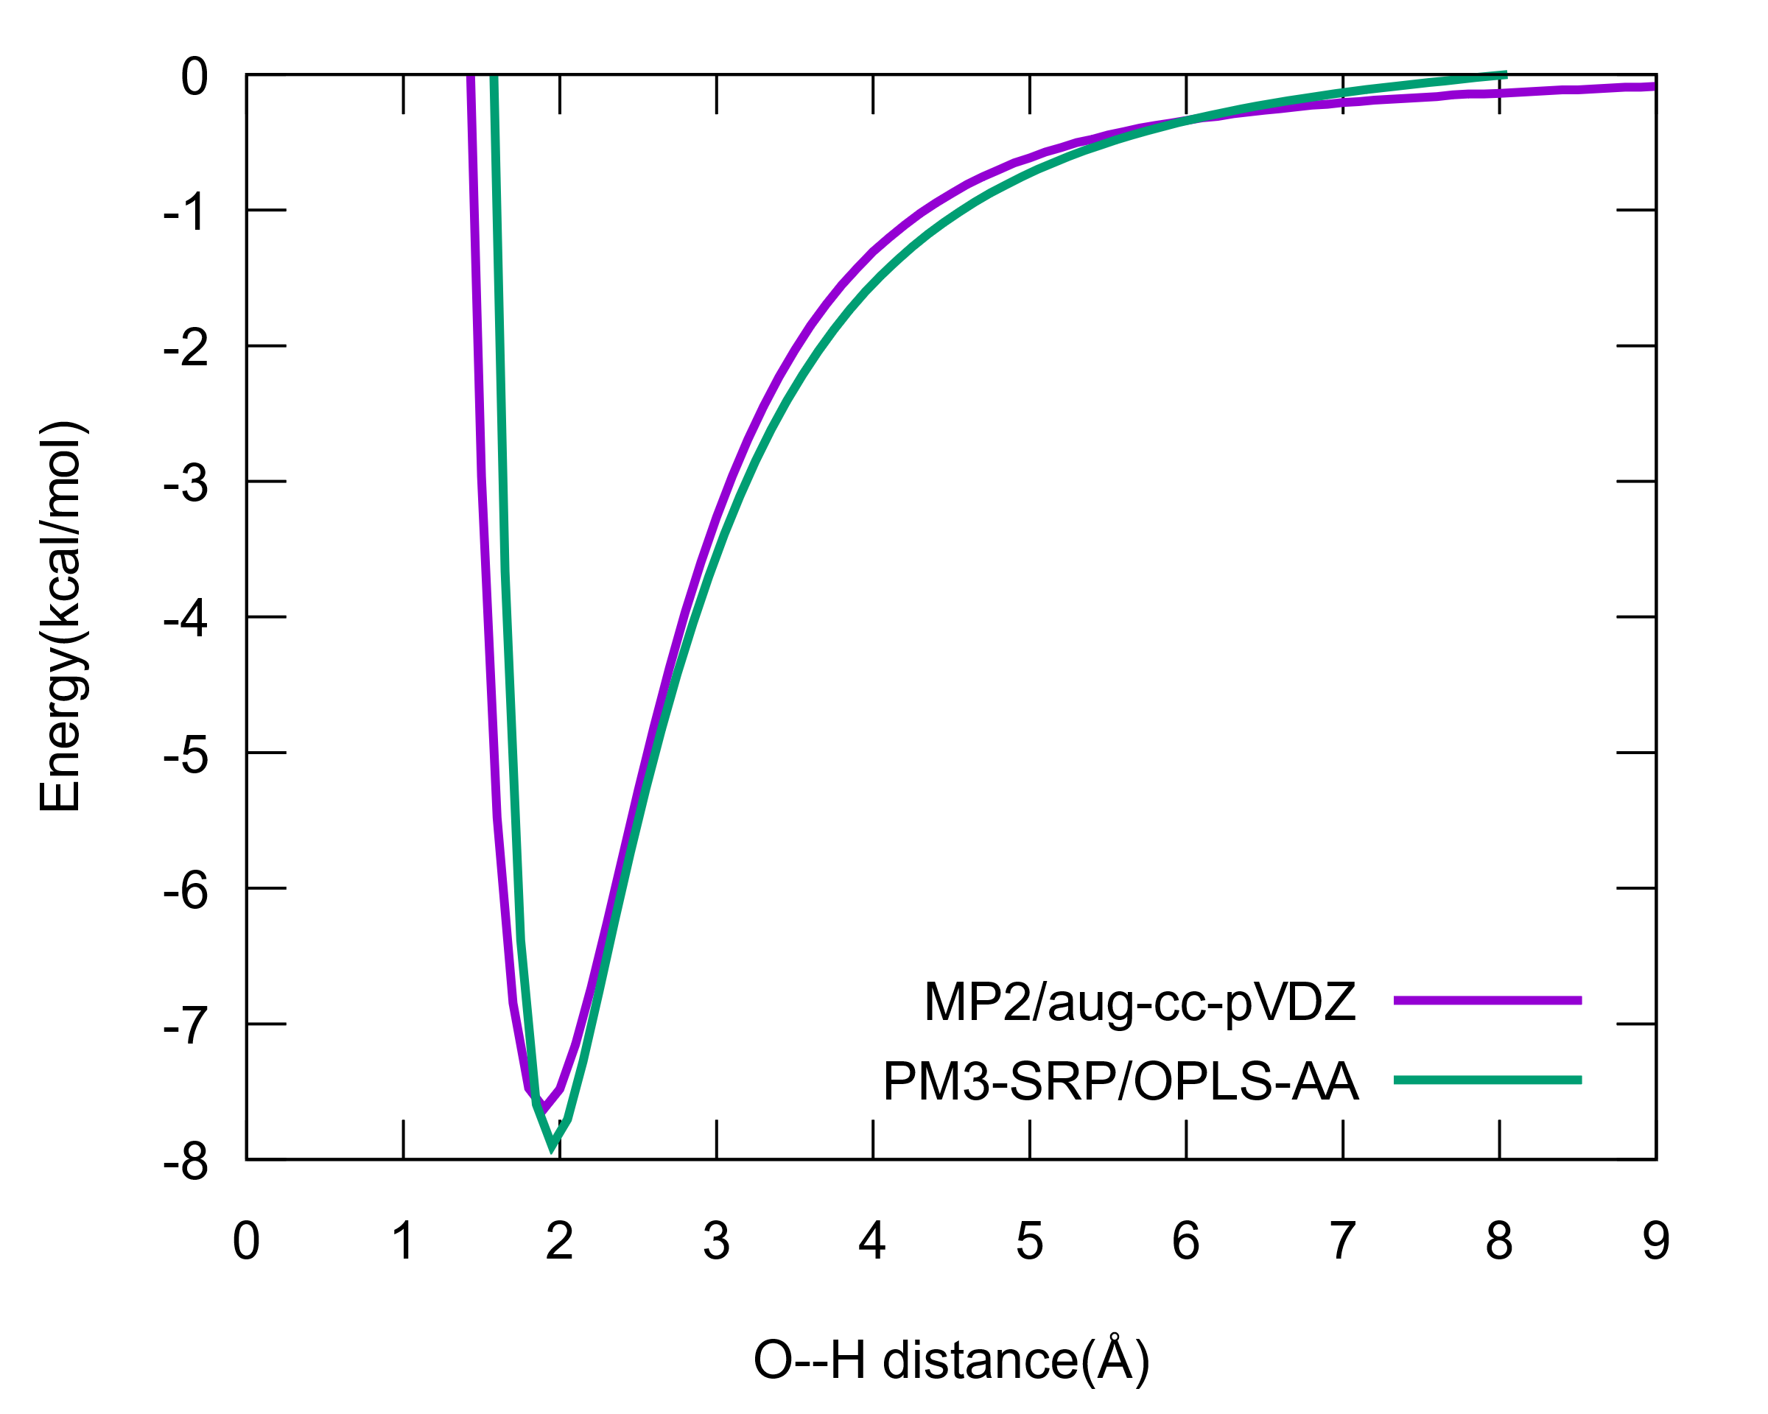

**Figure 4.** Rigid potential energy scan along the bond vector between oxygen of acetophenone and the donor hydrogen of methanol.

To adequately model the intermolecular dynamics between acetophenone and methanol, the Van der Waals radius of oxygen in the QM/MM interaction Hamiltonian was modified to yield the same binding energy as MP2/aug-cc-pvdz (-7.3 kcal/mol). The interaction potential between acetophenone and a single methanol molecule was computed by optimizing the geometry at the MP2 level, then performing a rigid potential energy scan along the acetophenone oxygen-methanol hydrogen vector. This was performed using the z-matrix facility in Gaussian (ref. needed), and translating the methanol molecule in Charmm respectively. Overall, the interaction potential between PM3-SRP/OPLS-AA and MP2/aug-cc-pVDZ compare very well.

Molecular dynamics were performed on the PM3-SRP for acetophenone in methanol. The computed FTIR spectrum displays a double crest with a splitting of 11.8 cm-1, which compares well with the experimental value of 12.1 cm-1. The peak position of the computed spectrum is about 10 cm-1 higher than it is in experiment. Overall, the specific reaction parameters optimized in this study increase the accuracy of the vibrational frequency compared to PM3.

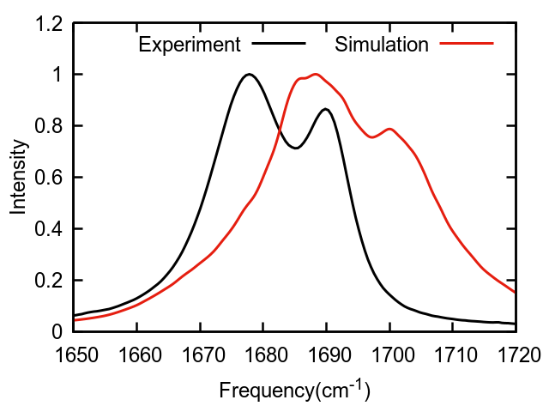

**Figure 5.** Simulated and experimental FTIR spectra for acetophenone in methanol

The solvation dynamics were studied using two-dimensional infrared spectroscopy (2DIR). Similar to FTIR, we observe two overlapping peaks at low waiting time (Tw). The simulated results show a larger inhomogeneous linewidth compared to experiment. As Tw increases, off-diagonal broadening occurs consistent with hydrogen bond exchange between acetophenone of methanol. From the off-diagonal intensity, it is possible to exchange the rate of exchange between hydrogen bonded states.64 The hydrogen bond lifetime extracted from the experimental 2DIR was 1 +/- 0.8 *ps*, while the simulated 2DIR yielded 2 *ps*, which is almost within the experimental error.

Furthermore, the hydrogen bond correlation function65, 66 yielded a lifetime of 2.8 *ps* in reasonable agreement to the simulated 2DIR, and further evinces the hypothesis that the separated peaks are due to different hydrogen bonding configurations. It is possible that the better agreement between these three lifetimes could obtained if the peaks were more resolved from one another. However, the radial distribution function between the oxygen of acetophenone and the hydrogen donor gives the average hydrogen bond occupation as the integral of the first peak. This yields an average hydrogen bond occupation of 1.7, which suggests that the hydrogen bond states being measured through spectroscopy are more likely to be the 1-2 hydrogen bond configurations rather than the normally assumed 0-1.58, 67, 68

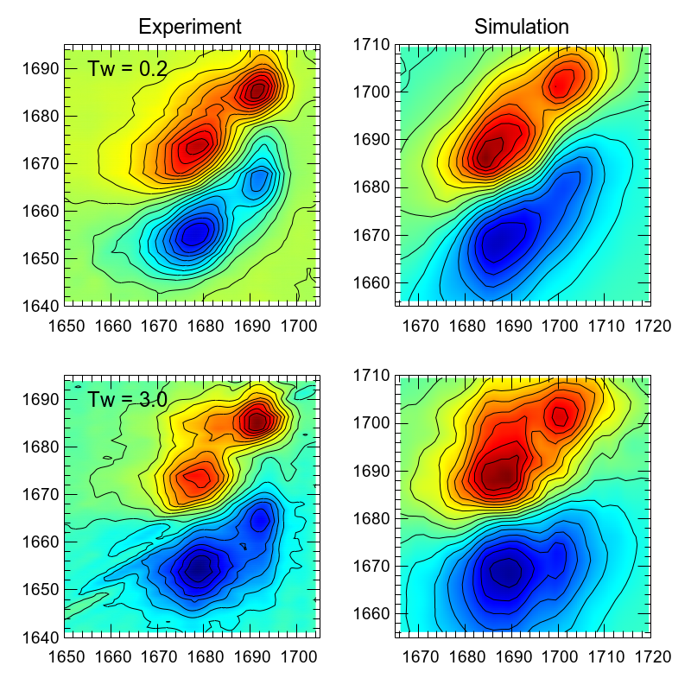

**Figure 6.** Simulated and experimental 2DIR for acetophenone in methanol. Simulations were performed with PM3-SRP/OPLS-AA.

**5. Concluding Remarks**

The simulation of 2DIR provides insight and context to experiment, and one of the usual requirements for modeling 2DIR is a frequency trajectory. Presented here is an implementation of quantum vibration perturbation theory (QVP) that requires very little effort on the part of the user, and provides a first principles quantum mechanical approach to computing frequency trajectories. During dynamics, the probe moves about, which means that the normal mode computed at one configuration is not necessarily applicable to another configuration. A coordinate transformation is shown here that allows for the transformation from one configuration to another such that the normal mode used at one configuration can be applied at a second configuration. There are two nontrivial components to this transformation. The first is the calculation of the rotation matrix between two frames of reference. A modification of the algorithm proposed by Arun *et al*.47 was presented to tailor the algorithm to this application, and resulted in a complete reduction of non-physical solutions. The second nontrivial component to the transformation is the displacement along internal modes, and was determined using constrained minimization, which led to a large reduction in the error associated with perturbation theory.

To test the implementation, the solvatochromism of acetophenone was modelled using QVP(2). Overall, the results showed reasonable agreement with respect to experiment, with a mean unsigned error of 2.2 cm-1 for the solvent shifts using PM3/OPLS-AA. Experimental FTIR of acetophenone in methanol showed a double crested peak, which was not observed in the computed results. A specific reaction parameter optimization of PM3 was performed to reproduce the average gas phase frequency of acetophenone, then the interaction potential between the solute and a methanol molecule was optimized to a high-level of theory. This PM3-SRP yielded a double crested peak in reasonable agreement with experiment. 2DIR was then simulated to test the capability of QVP(2) in modelling dynamics. Off-diagonal intensity was observed to be consistent with hydrogen bond exchange. The simulated hydrogen bond exchange was modestly slower than that measured experimentally, but is almost within the experimental error. The simulated results showing reasonable agreement to experiment suggests that the hydrogen bond configurations are the 1-2 hydrogen bond states instead of 0-1. Overall, this shows that QVP(2) can be applicable to systems with small differences in the vibrational frequency, such as a solvatochromic series or be used in monitoring dynamics through 2DIR.

ACKNOWLEDGMENT: The work was supported in part by grants from the National Institutes of Health and the National Natural Science Foundation of China.

REFERENCES

1 M. Cho, Chemical Reviews **108** (2008) 1331.

2 A. Ghosh, J. S. Ostrander, and M. T. Zanni, Chemical Reviews **117** (2017) 10726.

3 M. Reppert, and A. Tokmakoff, Annual Review of Physical Chemistry **67** (2016) 359.

4 J. C. Wright, Annual Review of Physical Chemistry **62** (2011) 209.

5 H. Kim, and M. Cho, Chemical Reviews **113** (2013) 5817.

6 M. T. Zanni, and R. M. Hochstrasser, Current Opinion in Structural Biology **11** (2001) 516.

7 F. Perakis *et al.*, (2016)

8 C. M. Olson *et al.*, The Journal of Chemical Physics **147** (2017) 124302.

9 Y. S. Kim, and R. M. Hochstrasser, Proceedings of the National Academy of Sciences of the United States of America **102** (2005) 11185.

10 Y. S. Kim, and R. M. Hochstrasser, Journal of Physical Chemistry B **111** (2007) 9697.

11 M. Reppert, and A. Tokmakoff, Journal of Chemical Physics **138** (2013)

12 L. Wang *et al.*, Journal of Physical Chemistry B **115** (2011) 3713.

13 J. R. Schmidt, S. A. Corcelli, and J. L. Skinner, Journal of Chemical Physics **121** (2004) 8887.

14 S. A. Corcelli, C. P. Lawrence, and J. L. Skinner, Journal of Chemical Physics **120** (2004) 8107.

15 J. H. Choi, and M. Cho, Journal of Chemical Physics **134** (2011)

16 B. Błasiak, H. Lee, and M. Cho, Journal of Chemical Physics **139** (2013)

17 M. Cho, Journal of Chemical Physics **118** (2003) 3480.

18 S. C. Edington, J. C. Flanagan, and C. R. Baiz, Journal of Physical Chemistry A **120** (2016) 3888.

19 T. La Cour Jansen, and J. Knoester, Journal of Chemical Physics **124** (2006)

20 T. Hayashi, W. Zhuang, and S. Mukamel, Journal of Physical Chemistry A **109** (2005) 9747.

21 S. Ham *et al.*, Journal of Chemical Physics **118** (2003) 3491.

22 B. Błasiak, and M. Cho, Journal of Chemical Physics **140** (2014)

23 H. Lee, J. H. Choi, and M. Cho, Journal of Chemical Physics **137** (2012) 0.

24 B. Błasiak, and M. Cho, Journal of Chemical Physics **143** (2015)

25 A. T. Fafarman *et al.*, Journal of the American Chemical Society **132** (2010) 12811.

26 S. D. Fried *et al.*, Journal of Physical Chemistry B **117** (2013) 16236.

27 S. D. Fried, S. Bagchi, and S. G. Boxer, Journal of the American Chemical Society **135** (2013) 11181.

28 G. U. Bublitz, and S. G. Boxer, Annual review of physical chemistry **48** (1997) 213.

29 S. D. Fried, and S. G. Boxer, Accounts of Chemical Research **48** (2015) 998.

30 S. S. Andrews, and S. G. Boxer, Journal of Physical Chemistry A **104** (2000) 11853.

31 S. H. Schneider, and S. G. Boxer, Journal of Physical Chemistry B **120** (2016) 9672.

32 S. G. Boxer, J. Phys. Chem. B **113** (2009) 2972.

33 N. M. Levinson, S. D. Fried, and S. G. Boxer, Journal of Physical Chemistry B **116** (2012) 10470.

34 M. Saggu, N. M. Levinson, and S. G. Boxer, Journal of the American Chemical Society **133** (2011) 17414.

35 M. Saggu, N. M. Levinson, and S. G. Boxer, Journal of the American Chemical Society **134** (2012) 18986.

36 R. Shrestha *et al.*, Journal of Physical Chemistry B **119** (2015) 2869.

37 S. D. Fried, S. Bagchi, and S. G. Boxer, Science **346** (2014) 1510.

38 R.-J. Xue *et al.*, Journal of Chemical Theory and Computation **13** (2016) 191.

39 B. R. Brooks *et al.*, Journal of computational chemistry **30** (2009) 1545.

40 D. T. Colbert, and W. H. Miller, Journal of Chemical Physics **96** (1992) 1982.

41 J. C. Light, and T. Carrington, Advances in Chemical Physics **114** (2000) 263.

42 R. G. Littlejohn *et al.*, Journal of Chemical Physics **116** (2002) 8691.

43 J. C. Light, I. P. Hamilton, and J. V. Lill, The Journal of Chemical Physics **82** (1985) 1400.

44 J. n. Echave, and D. C. Clary, Chemical Physics Letters **190** (1992) 225.

45 H. Wei, and T. Carrington, The Journal of Chemical Physics **97** (1992) 3029.

46 I. Mayer, *Simple Theorems, Proofs, and Derivations in Quantum Chemistry* (Springer Science+Business Media, LLC, 2003),

47K. S. Arun, T. S. Huang, and S. D. Blostein, IEEE Trans. Pattern Anal. Mach. Intell. () **9** (1987) 698.

48 J. J. P. Stewart, J. Comput. Chem. **10** (1989) 209.

49 J. J. P. Stewart, Journal of Computational Chemistry **10** (1989) 221.

50 J. J. P. Stewart, Journal of Computational Chemistry **12** (1991) 320.

51 W. L. Jorgensen, D. S. Maxwell, and J. Tirado-Rives, J. Am. Chem. Soc. **118** (1996) 11225.

52 N. A. McDonald, and W. L. Jorgensen, J. Phys. Chem. B **102** (1998) 8049.

53 M. Cho, *Two-Dimensional Optical Spectroscopy* 2009),

54 S. Mukamel, *Principles of nonlinear optical spectroscopy* (Oxford University Press, New York; Oxford, 1999),

55 J. L. Skinner, Molecular Physics **106** (2007) 2245.

56 J. H. Choi, K. W. Kwak, and M. Cho, Journal of Physical Chemistry B **117** (2013) 15462.

57 K. Kwac, H. Lee, and M. Cho, Journal of Chemical Physics **120** (2004) 1477.

58 S. H. Schneider *et al.*, Journal of Physical Chemistry B **121** (2017) 2331.

59 A. P. Scott, and L. Radom, The Journal of Physical Chemistry **100** (1996) 16502.

60 A. F. M. Barton, Chemical Reviews **75** (1975) 731.

61 M. V. Garcia, and M. I. Redondo, Spectrochimica Acta Part A: Molecular Spectroscopy **43A** (1987) 879.

62 I. Rossi, and D. G. Truhlar, Chemical Physics Letters **233** (1995) 231.

63 K. Nam *et al.*, Journal of Chemical Theory and Computation **3** (2007) 486.

64 M. D. Fayer, Annu. Rev. Phys. Chem.u **60** (2009) 21.

65 N. Michaud-Agrawal *et al.*, Journal of computational chemistry **32** (2011) 2319.

66 R. J. Gowers, and P. Carbone, Journal of Chemical Physics **142** (2015)

67 L. Chuntonov *et al.*, Journal of Physical Chemistry B **119** (2015) 4512.

68 I. M. Pazos *et al.*, Angewandte Chemie - International Edition **53** (2014) 6080.